International Darth Vader

Mobile Application User Guide

December 09th, 2016

TABLE OF CONTENTS

1. Introduction ……………………………………………………………………... Pg. 2

2. Device Requirements ……………………………………………...………….… Pg. 2

3. Installation …………………………………………………………………...….. Pg. 4

4. Application Usage ……………………………………………………..……...… Pg. 7

4.1 Splash-Screen ……………………………………………..…………… Pg. 7

4.2 Navigation: Upload …………………………………………………….. Pg. 8

4.2.1 Title and Tags ………………………………………………… Pg. 9

4.2.2 Explicit Marker ………………………………………….……. Pg 10

4.2.3 Record and Stop Record Buttons …………………………….. Pg 11

4.2.4 Preview Button ……………………………………………..… Pg 13

4.2.5 Upload Button ………………………………………………... Pg 13

4.3 Navigation: Play ………………………………………………………... Pg 14

4.3.1 Clip List ………………………………………………………. Pg 15

4.3.2 Filters ………………………………………………………..... Pg 18

4.3.3 Refresh Button ………………………………………………... Pg 21

4.3.4 Play Button ………………………………………………….... Pg 22

4.3.5 Search Tag, Explicit Tag, Apply Button ……………………... Pg 24

5. Bluetooth ……………………………………………………………………….... Pg. 29

6. Questions about this Mobile App ………………………………………………... Pg. 30

**1 Introduction**

The International Darth Vader mobile application acts as the medium by which users can interact with the International Darth Vader product through their mobile device. The app allows users to:

* Record audio clips for up to 15 seconds
* Playback recorded audio
* Upload audio clips to Amazon Web Services database
* Select a clip to play through the Darth Vader module
* Apply a filter to an audio clip
* Search for audio clips to play

This user guide will help users to successfully navigate through the app to aid in achieving an enjoyable experience with the International Darth Vader product.

**2 Device Requirements**

Prior to installation, please note that your device must be running Android version 4.3.0 and above (Android Jelly Bean or higher). If you are unsure of what version your device is running, please navigate to your device settings and “About” page, and review the “Android Version” portion of the device information. Figures 1, 2, and 3 illustrate the process to find the Android version on an Android device[1]. If your device is running an Android version lower than 4.3.0, the application may not work as some of the features may not be accessible on earlier versions of Android.

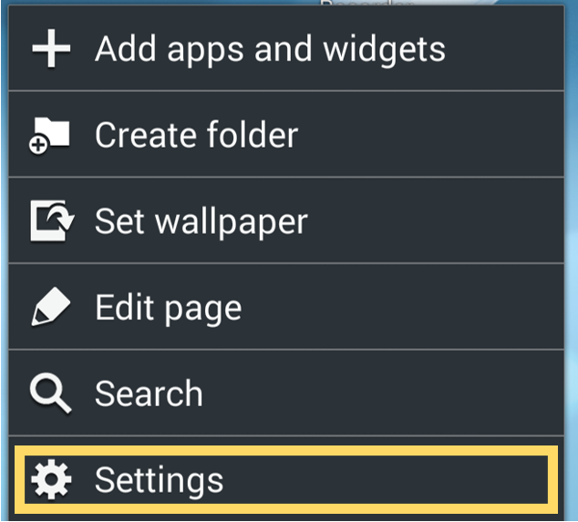

Figure 1: Navigate to Settings

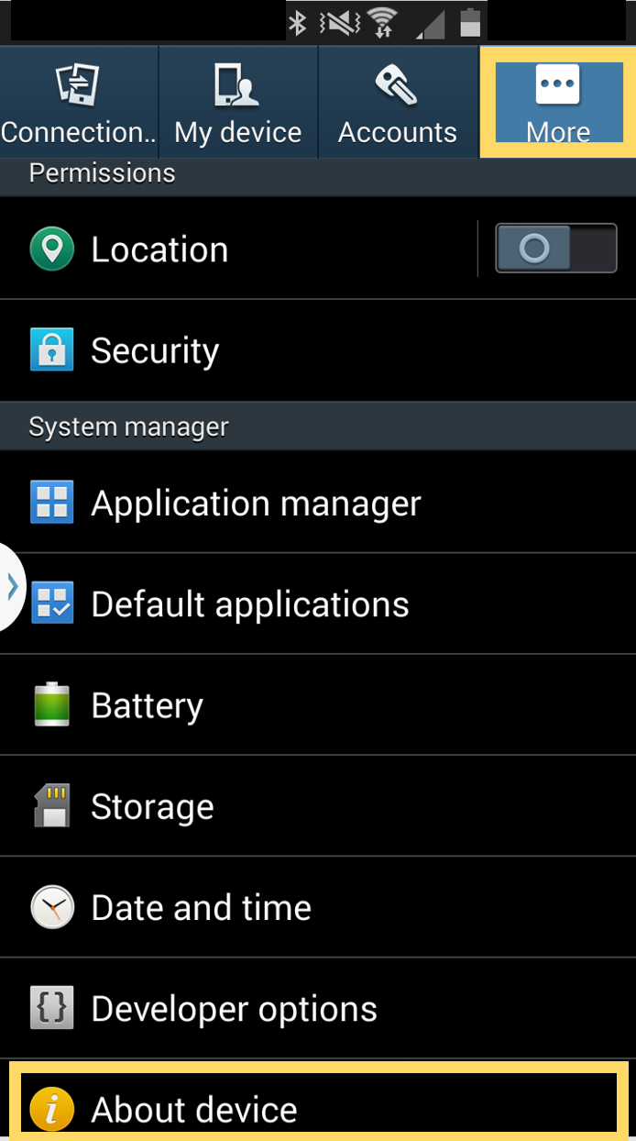

Figure 2: Select “More”, find and select “About device”

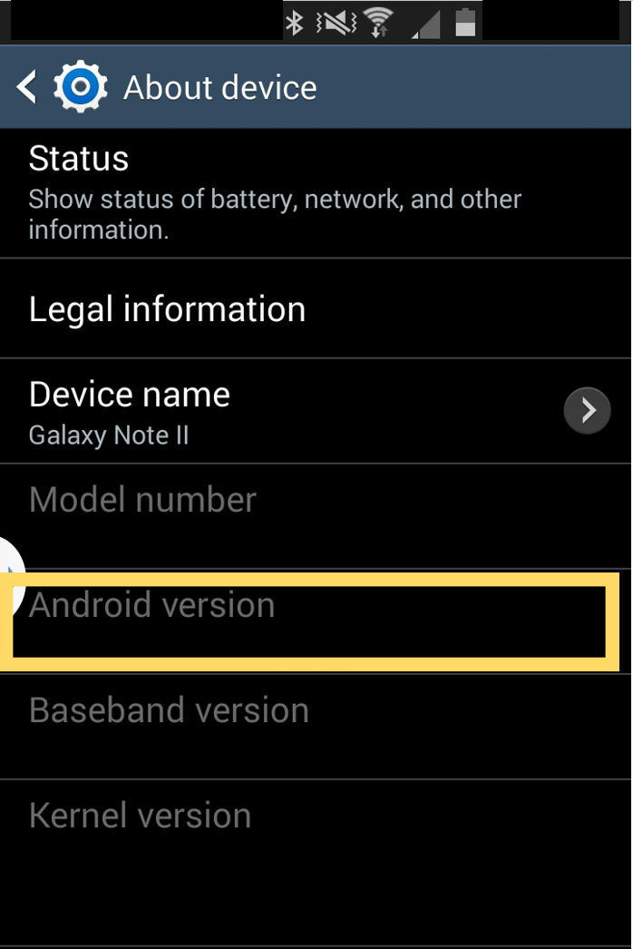

Figure 3: Verify Android Version within “About device”

**3 Installation**

To install the mobile application, the user must have the latest version of the .APK file. Figure 4 illustrates what a .APK file would look like in the File Explorer on a Windows system. To load this file onto an Android client, plug the device into your computer via USB cable, and move the file onto the phone’s storage. Once the file has been transferred, the application should be available in the phone’s application list. The application is titled **IDV** and has a Darth Vader helmet thumbnail image for the icon.

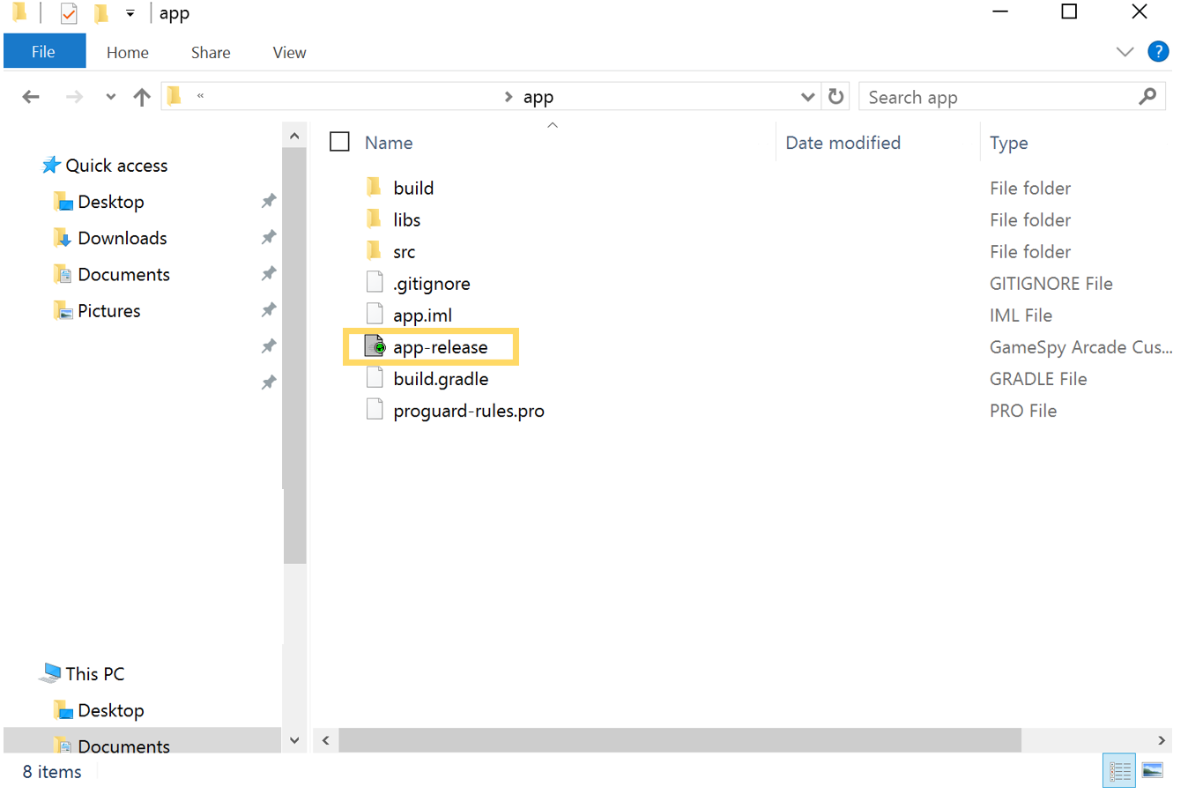

Figure 4: .APK file (on Windows 10)

If the .APK file is accessible online, it can be downloaded by simply tapping the app icon titled **IDV** and the app will begin downloading to your phone. Figures 5 and 6 illustrate this action with downloading the .APK file from an online cloud storage service.

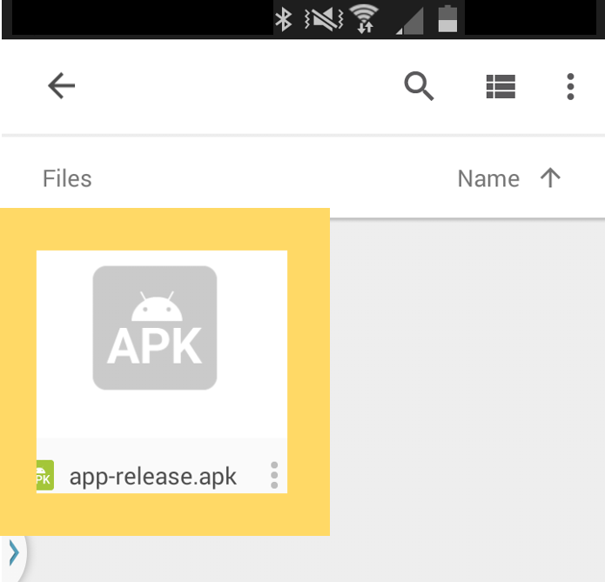

Figure 5: Tap on the .APK file on the device

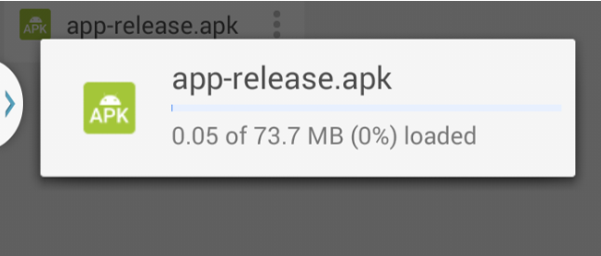

Figure 6: App begins downloading to device

Once the app has finished downloading, you will be prompted with an installation request from the application to your device. This query will be followed by a list of services the app will access when it is running (see Figure 7). The **IDV** mobile application will request access to the microphone for recording audio, the ability to read and write files to your device’s storage locations for audio files, the use of wireless network data for uploading files, and the use of Bluetooth for sending commands to the International Darth Vader product[2].

Tap “Install” to begin installation of the application to your device. Figures 8 and 9 illustrate what to expect when installation begins and successfully completes. Once installation is complete, tap “Open” and the application will start. If you select “Done”, the installation window will close and the application will not start. To access the application after installation, go to your applications list and search for **IDV**. Once it appears, tap the icon to start the application.

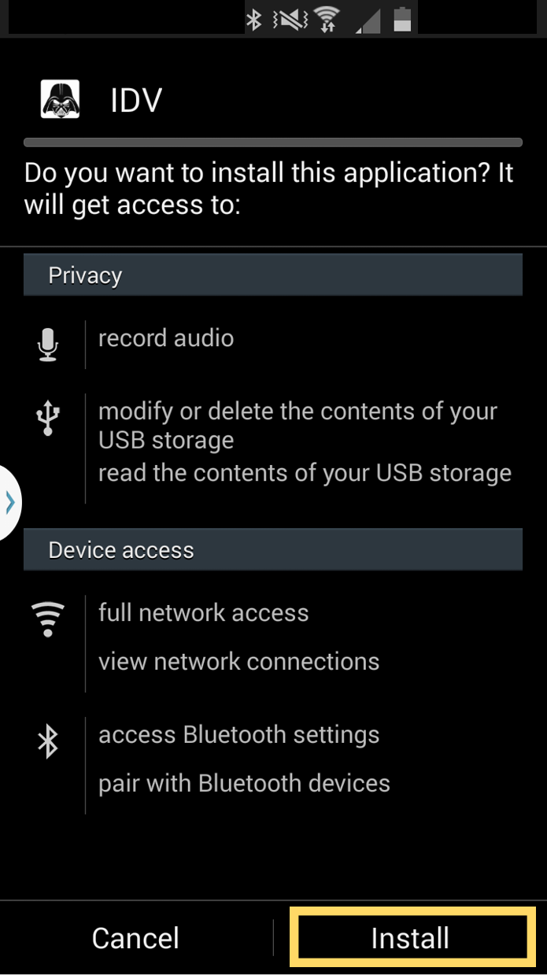

Figure 7: Request to install application

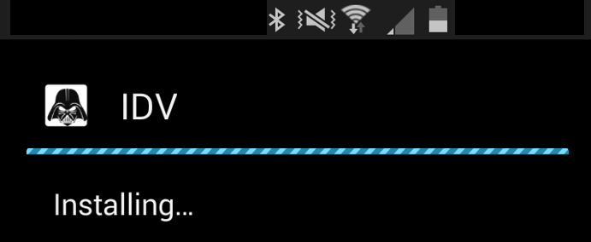

Figure 8: Application installing to device

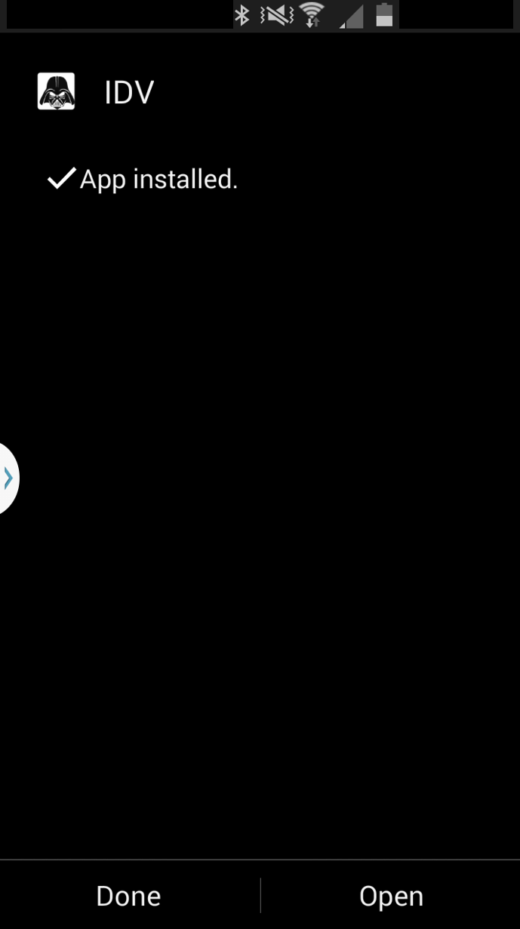

Figure 9: Application successfully installed

**4 Application Usage**

When the application is running, you will have the option to navigate through three different screens: the splash, upload, and play screens. Each screen serves a different purpose when interacting with the International Darth Vader product.

**4.1 Splash-Screen**

The splash-screen is what you will see when the application initially starts. This screen shows a short animation of the company logo with some background music (see Figure 10). The splash screen gives the application time to construct and load properly. This screen will not reappear if you switch between the IDV application and other applications. The splash-screen will appear again if the application is closed completely and then reopened.

In order to bypass the splash screen upon start-up, simply tap anywhere on the touchscreen and you will be directed to the Upload screen.

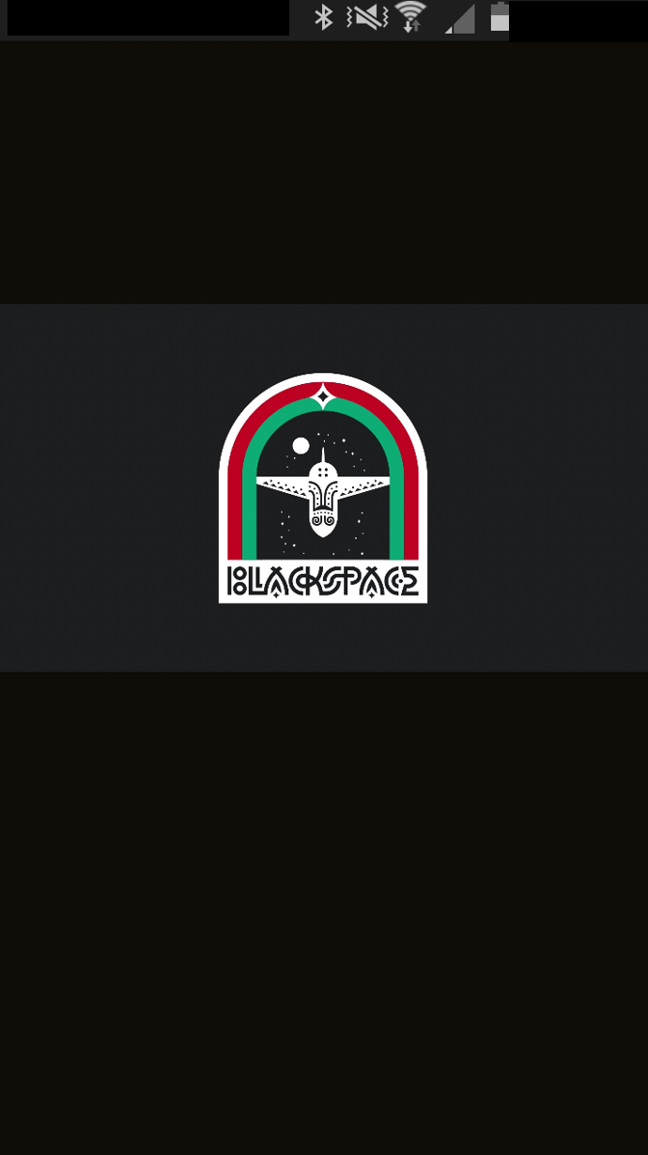

Figure 10: Preview of Splash Screen

**4.2 Navigation: Upload**

The Upload screen is where a user can record and upload audio clips from their mobile device. Figure 11 shows the general layout of the Upload screen upon application startup. The layout features an area to give your audio clip a title, apply hashtags[3] to your clip, and mark your audio clip as explicit. Once information has been filled out, four buttons follow for audio creation: Record, Stop Record, Preview, and Upload.

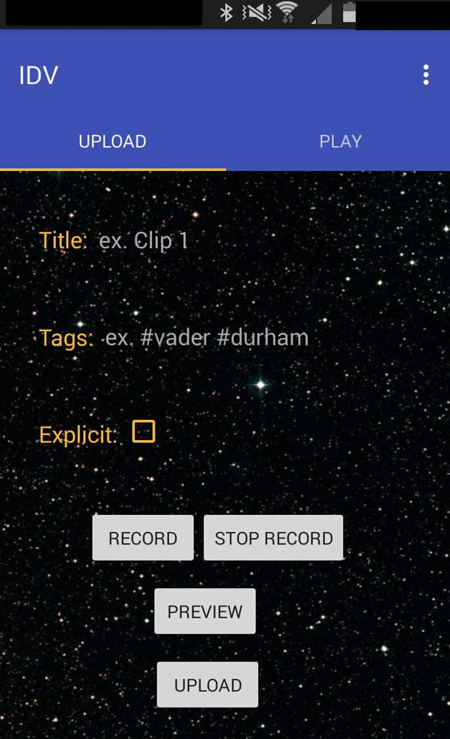

Figure 11: Upload screen layout

**4.2.1 Title and Tags**

To give your audio clip a title or apply a hashtag, tap in either of the fields and a pop-up dialog box should appear (see Figure 12). Once you tap either of the areas for “Title” or “Tag” in the dialog box, the keyboard should appear giving you the ability to type in your desired field.

***Note:*** *The use of hash or pound (#) in front of each tag is entirely optional. Be advised that neither tags nor titles should contain the forward slash or backward slash ( “/” or “\”) in its field when submitted. This may result in unexpected system behavior.*

It is completely optional to give your audio clip a title or tags. If an audio clip is not given a title, it will be given the default title “VoiceXX” where “XX” represents a number. By default no tags will be applied to an audio clip.

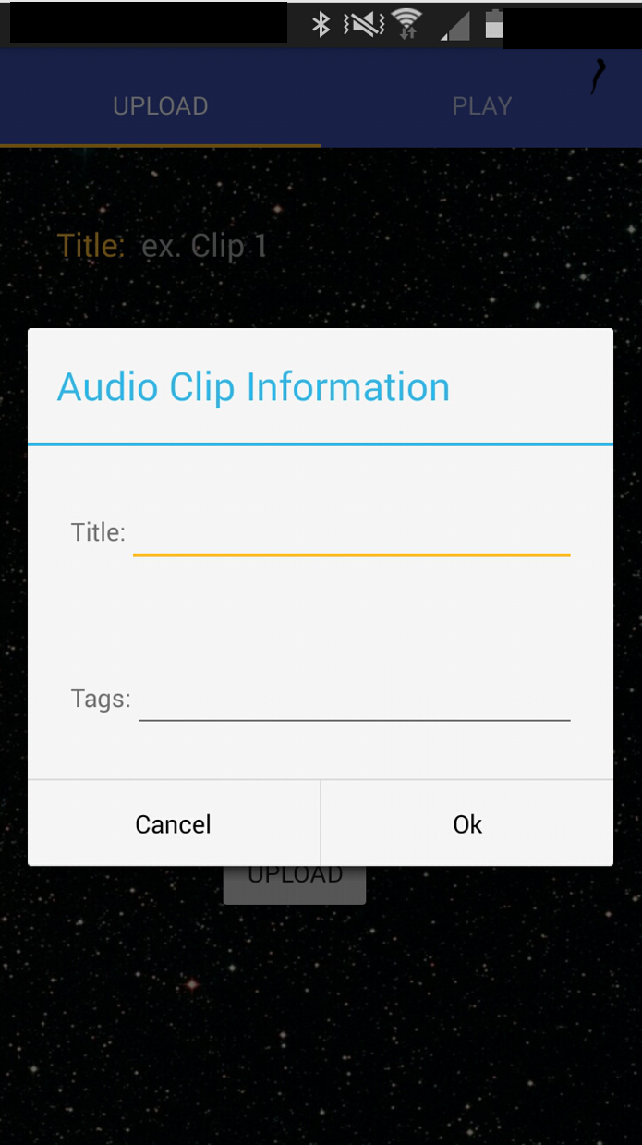

Figure 12: Dialog box to enter audio clip information

**4.2.2 Explicit Marker**

If you feel your audio clip is explicit in nature, you may choose to mark the audio clip as “Explicit”. This can be done by tapping the outlined orange square next to “Explicit” seen in Figure 11. Once the box has been tapped, it will show a small check mark as seen in Figure 13. By default, the explicit check mark is unchecked. Please remember that your content may reach students under the age of 18.

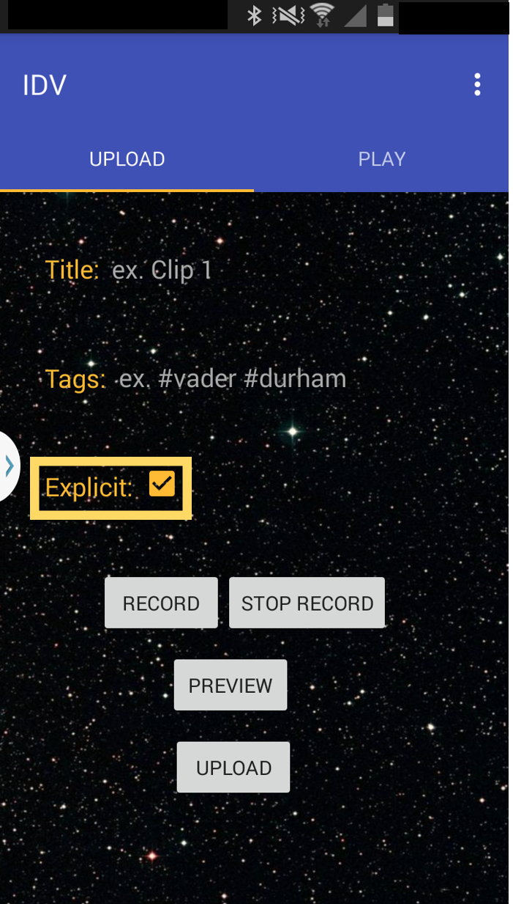

Figure 13: Checkbox shown for Explicit content

**4.2.3 Record and Stop Record Buttons**

Audio clips can be created using the “Record” and “Stop Record” buttons. To create a new audio clip, press the “Record” button and begin speaking into the microphone on your device. Each recording must be no more than 15 seconds long. Once this button is pressed, a counter will appear just to the left of the button counting down from “15” (see Figure 14). Once the counter reaches “0” and disappears, the recording will automatically be stopped. If you finish your recording prior to the counter reaching “0”, tap “Stop Record” and the application will stop and save the recording.

If you press “Record” after you have already pressed “Stop Record”, a new recording will begin and overwrite what was previously recorded[4].

If you press “Record” and the “Title” section was left blank, a message will appear at the bottom of the screen informing you that the title of the audio clip will be “VoiceXX”.

The recordings do not have to be from the user’s voice. Recordings can come from other audio sources such as a musical instrument, speaker-any other source, but each recording will only be 15 seconds long.

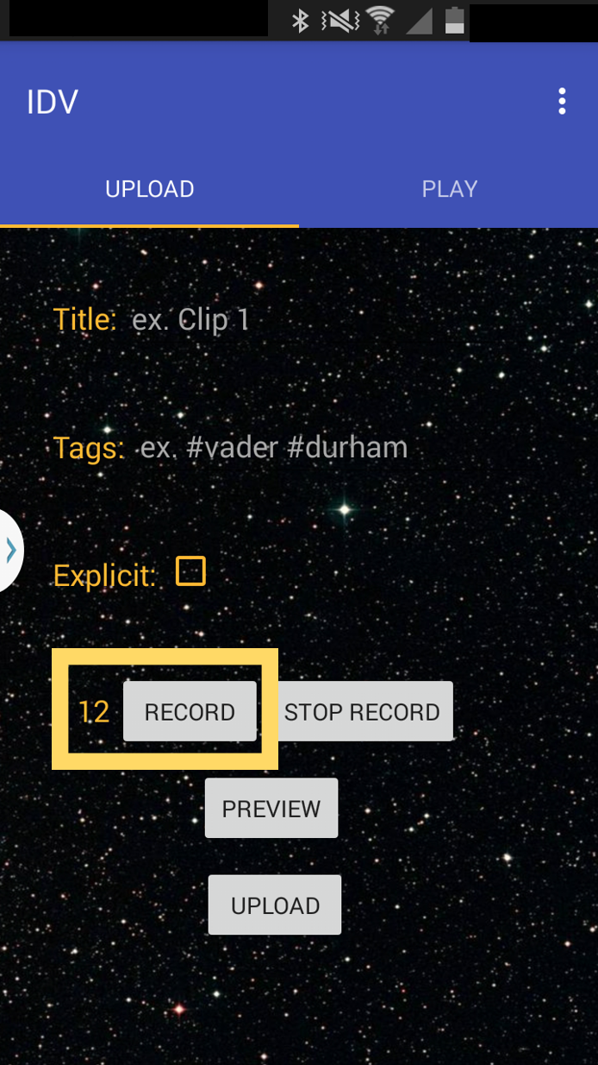

Figure 14: Record audio counter

**4.2.4 Preview Button**

If you would like to hear the recording you created before uploading, tap the “Preview” button to playback your recorded audio from the device’s speakers. Make sure to have your device volume set so that you can hear the recording

.

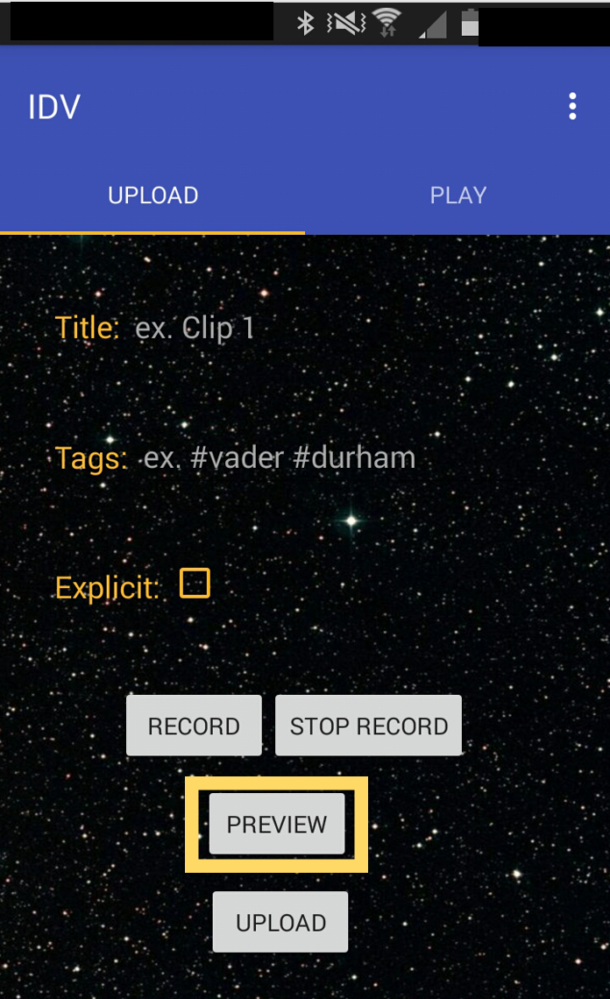

Figure 15: Preview audio

**4.2.5 Upload Button**

When you are ready to upload your recording, tap the “Upload” button. Once the file upload has completed and was successful, a message should appear briefly at the bottom of the screen displaying a confirmation message, “Upload successful.”

For an upload to be successful two requirements must be met:

1. The mobile device must be connected to a wireless network, and

2. An audio clip recording must be ready to upload.

If either requirement is not met, you will be prompted to take action with a message at the bottom of the screen. If both requirements have been met, and you are experiencing issues uploading the audio clip, completely close out of and restart the application. If the issue persists, contact the mobile application developer (see Section 6).

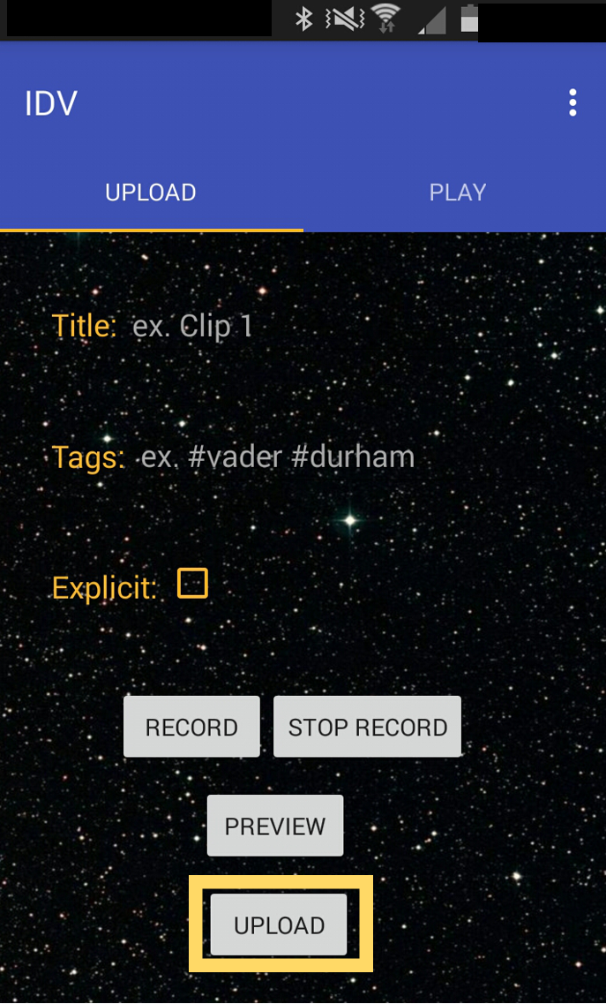

Figure 16: Upload button

**4.3 Navigation: Play**

The Play screen is where a user can select an available audio clip from their mobile device and play it through the International Darth Vader product. Figure 17 shows the general layout of the Play screen upon application startup. The layout features an area where a list of available audio clips will be populated, audio modulation filters, a Refresh button, and a Play button. The user also has the option to search for audio clips by their hashtags and explicit nature with the Search Tag area and Explicit Tag checkbox. The Apply button allows the user to be able to complete their search based on the information provided in the Search Tag area and the Explicit Tag checkbox.

Please note that in order to be able to use all the features from the Play screen, Bluetooth must be enabled on the mobile device, and the device must be paired with an International Darth Vader product.

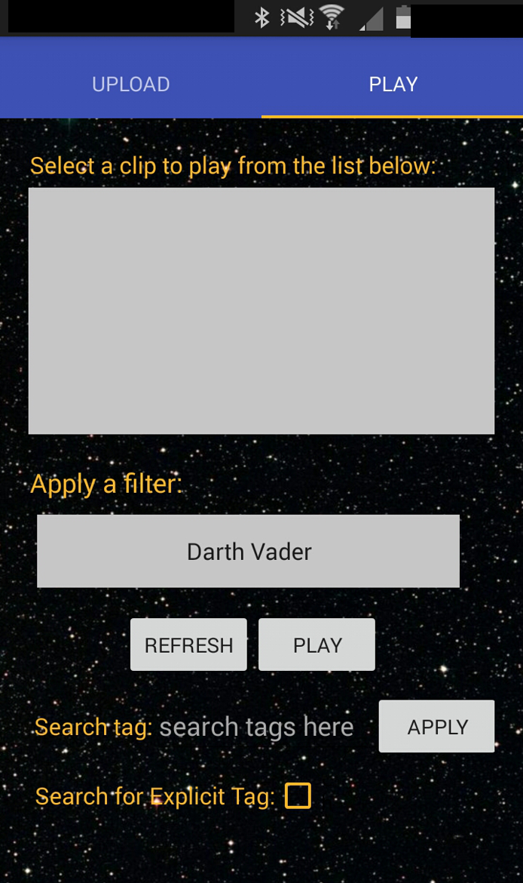

Figure 17: Layout of Play Screen

**4.3.1 Clip List**

The clip list is the area that will show all the available clips that can be selected to be played through the International Darth Vader product (see Figure 18).

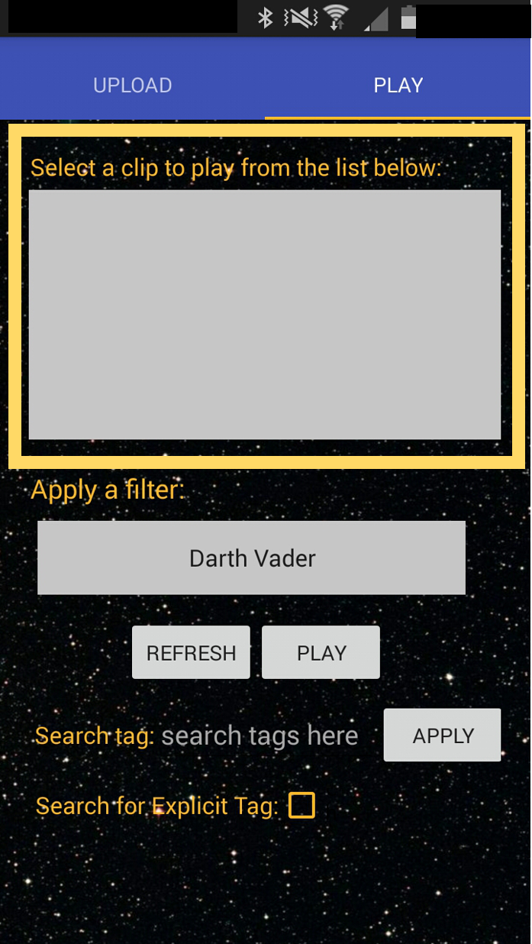

Figure 18: Clip list area

Upon startup the list will be empty. To populate the clip list, press the “Refresh” button and the list of clips should appear. Figures 19 and 20 illustrate the process of pressing the “Refresh” button and seeing the clips appear in the clip list area.

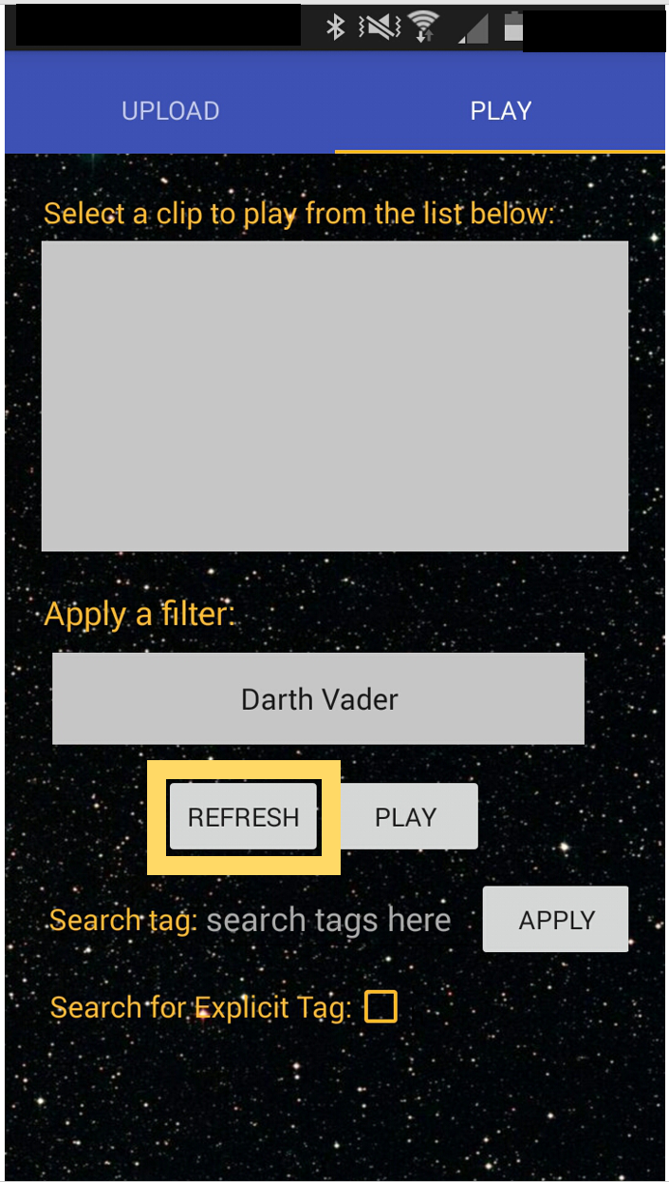

Figure 19: Press “Refresh” button to populate clip list

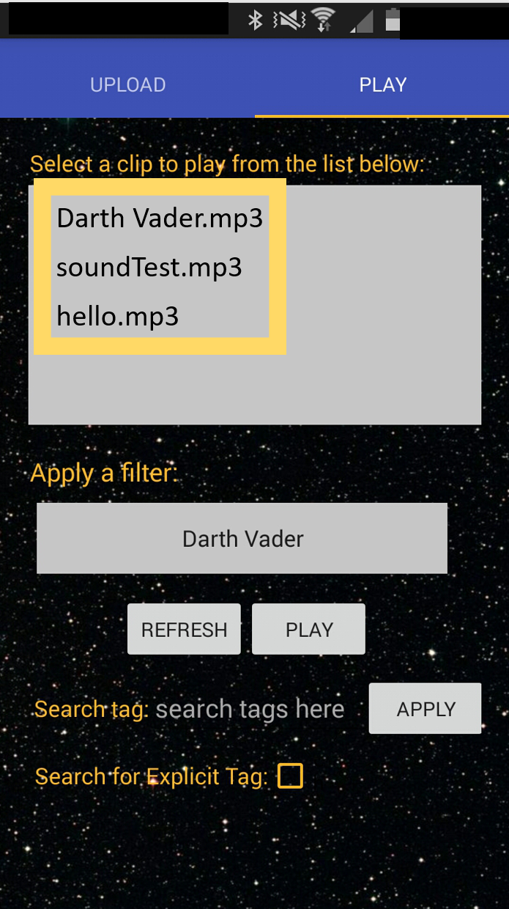

Figure 20: Clips are now displayed in clip list area

**4.3.2 Filters**

After a clip is selected, users have the option of adding audio modulation to the clip. To apply a filter, first select the clip you would like to play. Then, tap the area just below the heading “Apply a filter:” and a dialog box should appear with a list of available filters. When you see a filter you’d like to apply, tap it, and the dialog box should close. Now, the selection for “Apply a filter:” should show the filter you selected. Figures 21-23 illustrate this process.

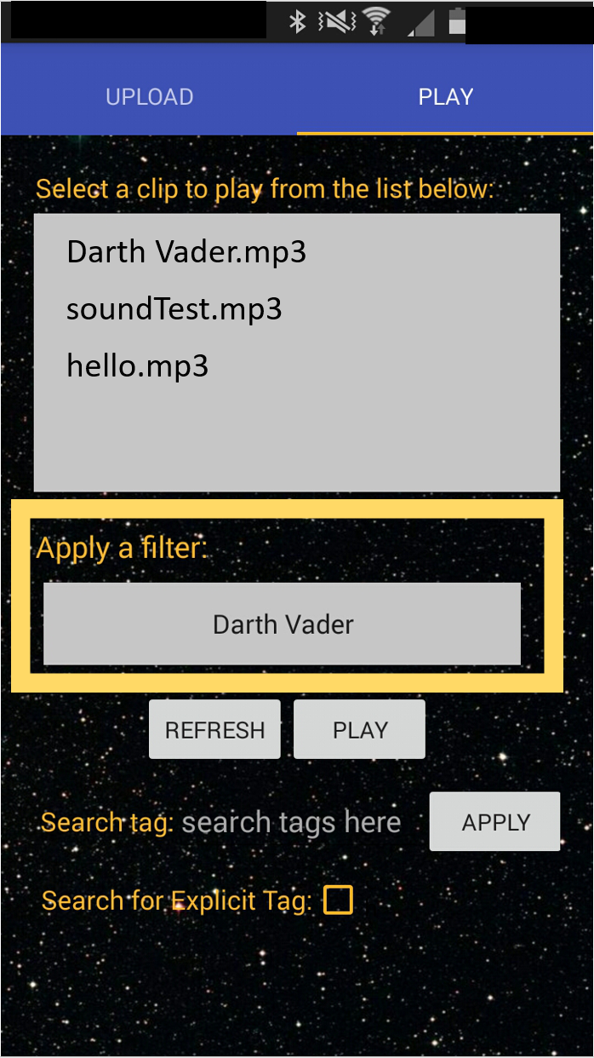

Figure 21: Apply a filter area

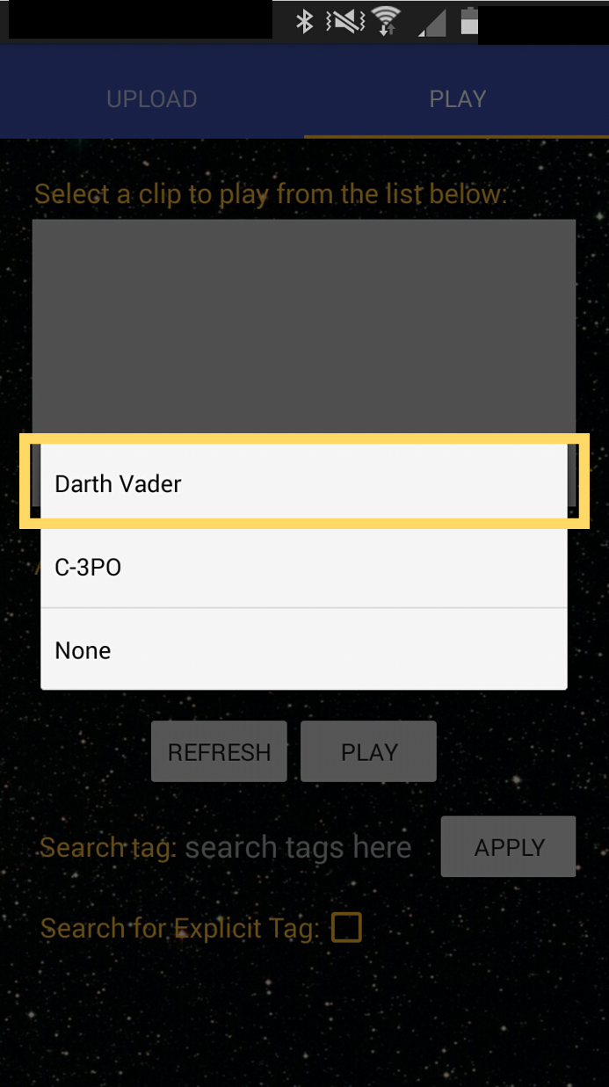

Figure 22: List of filters to apply to audio clip

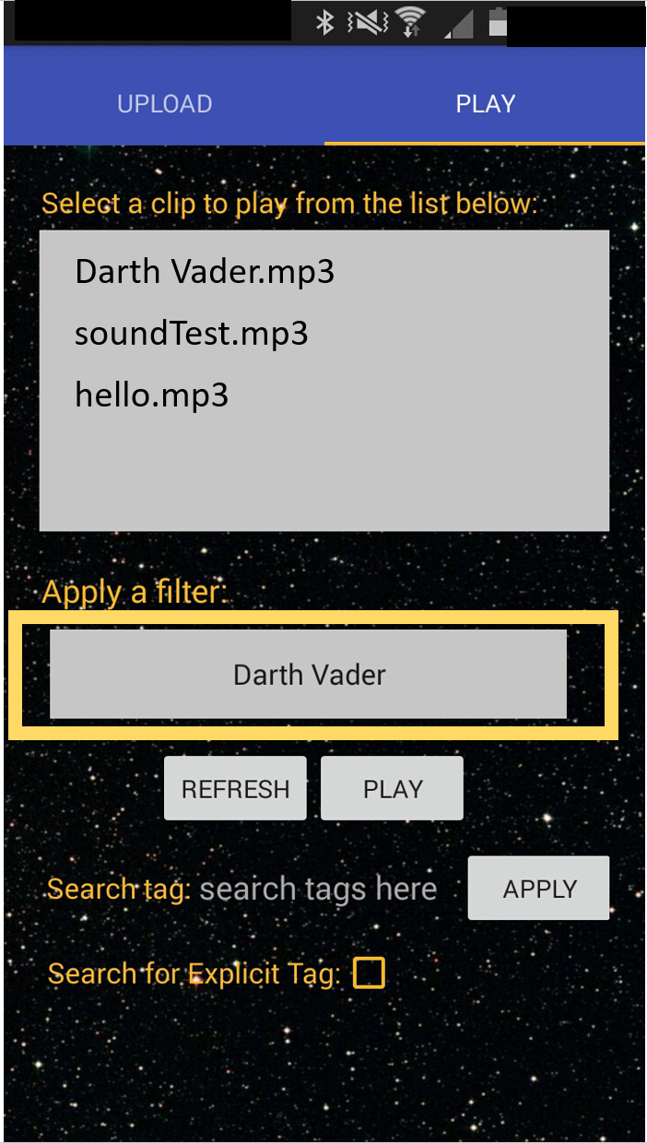

Figure 23: Selected filter (Darth Vader) is displayed

Please note that the default audio filter is set to “Darth Vader”. If you wish to apply a different filter to your audio clip, or not apply an audio filter at all, please make sure to change the filter prior to pressing the “Play” button.

**4.3.3 Refresh Button**

The “Refresh” button keeps the clip list updated with the latest changes made by users using the mobile application. Such changes would be retrieving new audio clips that have been uploaded by other users or using the “Search tag” function within the app as well (see section 4.3.5). Overall, this button is vital in ensuring that the mobile application is displaying the most up-to-date information to the user while on the “Play” screen. If new clips do not appear, the International Darth Vader product may be experiencing network connectivity issues or a slow internet connection. Please ensure that the International Darth Vader product is connected to the internet and give it up to 30 minutes to synchronize (worst-case scenario).

**4.3.4 Play Button**

The “Play” button is what allows the user to be able to play audio clips through the International Darth Vader product via Bluetooth from the mobile application. To achieve this, you must first select a clip to play as seen in Figure 24. Only one clip can be played at a time. Once you have selected a clip (and applied a filter if desired), tap the “Play” button (see Figure 25). A message should appear at the bottom of the screen that says the clip is playing on the International Darth Vader product.



Figure 24: Available clips that can be selected to play

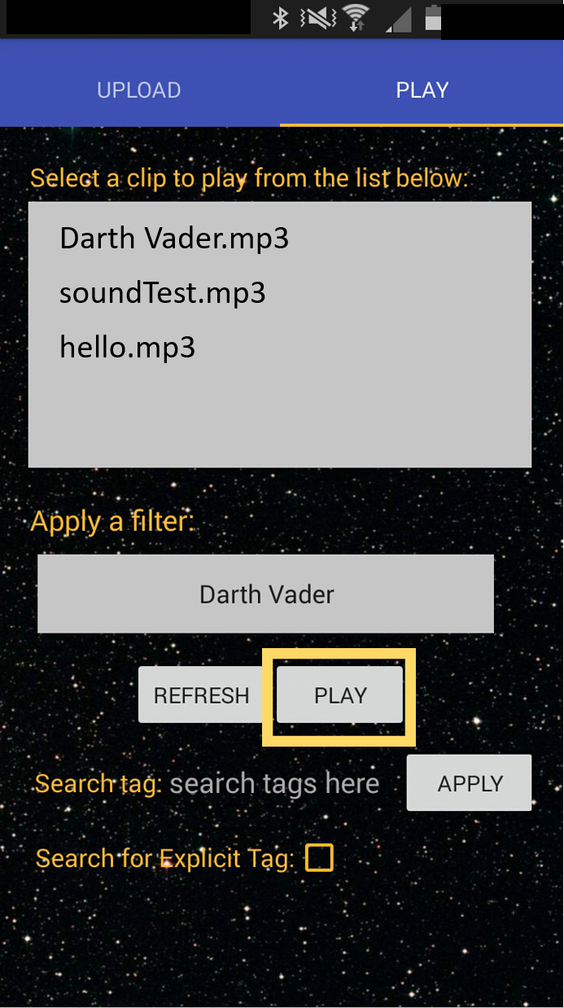

Figure 25: Press the “Play” button when you’re ready to play a clip

**4.3.5 Search Tag, Explicit Tag, Apply Button**

The remaining items on the “Play” screen are the “Search tag” area, “Explicit tag” checkbox, and the “Apply” button. These three items are additional features for the user but are not required in interacting with the International Darth Vader product.

If you would like to search for a clip that contains a specific tag, first tap in the area just to the right of the “Search tag:” text. Once you tap there, a dialog box should appear where you may type the specific tag (or tags) you would like to apply to your search. When you have finished typing, be sure to tap “Ok”.

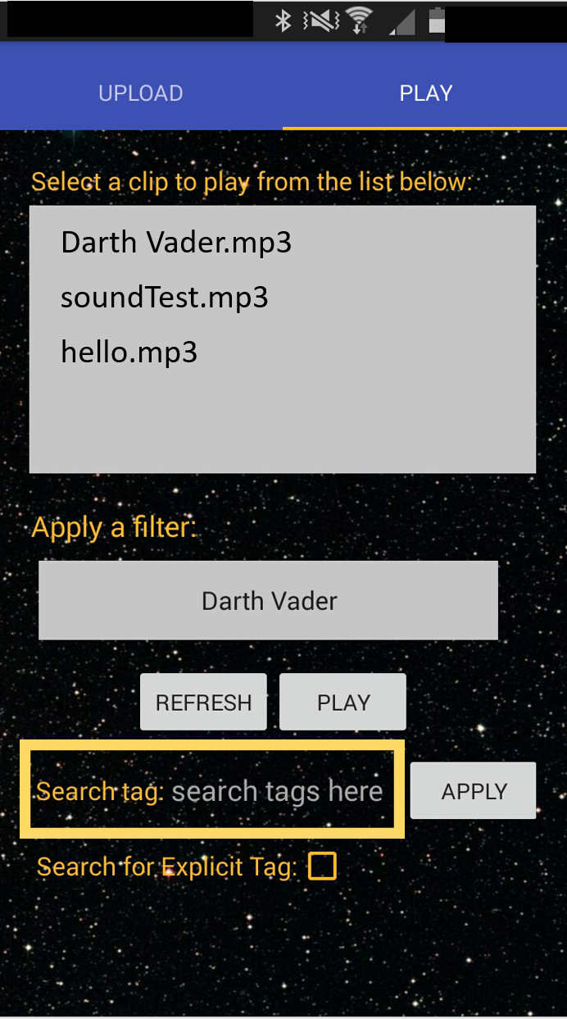

Figure 26: “Search tag:” area

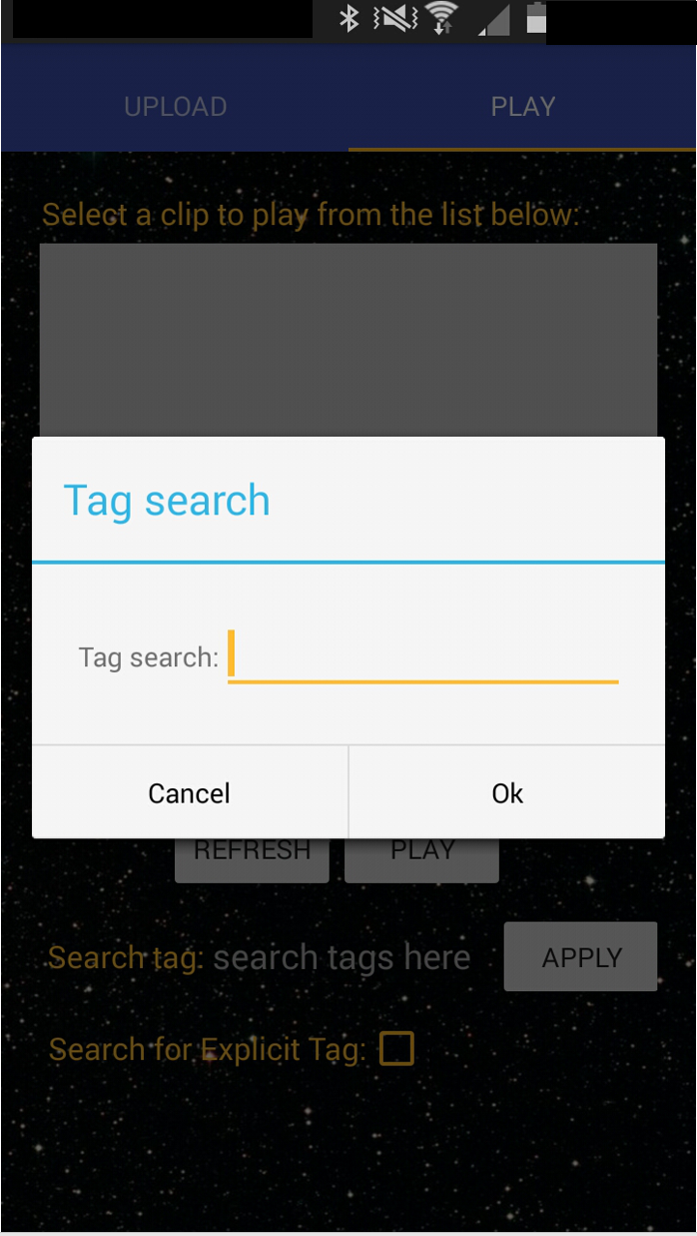

Figure 27: Dialog box for searching by tags

Additionally, if you would like to search for clips that are also explicit in nature, tap the orange square outline to the right of “Search for Explicit Tag:”. Once this is tapped, a checkmark will appear in the box. Because this feature is optional, the box is left unchecked by default.

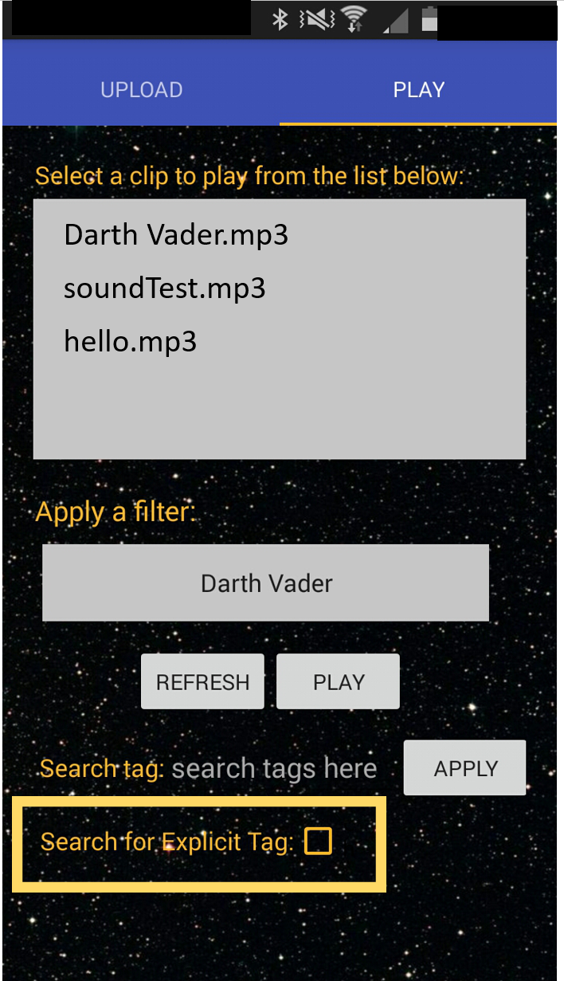

Figure 28: “Explicit Tag” checkbox to search for explicit content

Once you are ready to apply your search, tap the “Apply” button. A message should then appear near the bottom of the screen that explains that the “Refresh” button must then be pressed to see your changes. Press the “Refresh” button, and then your search results will display in the clip list area. Figures 26-30 illustrate the process of searching for tags and displaying the results of the search.

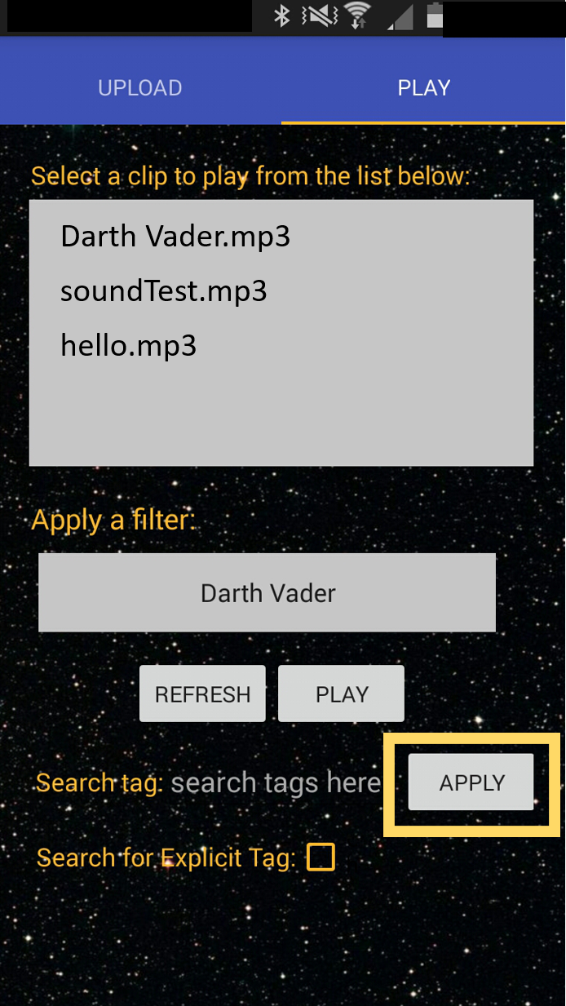

Figure 29: Press the “Apply” button to apply search

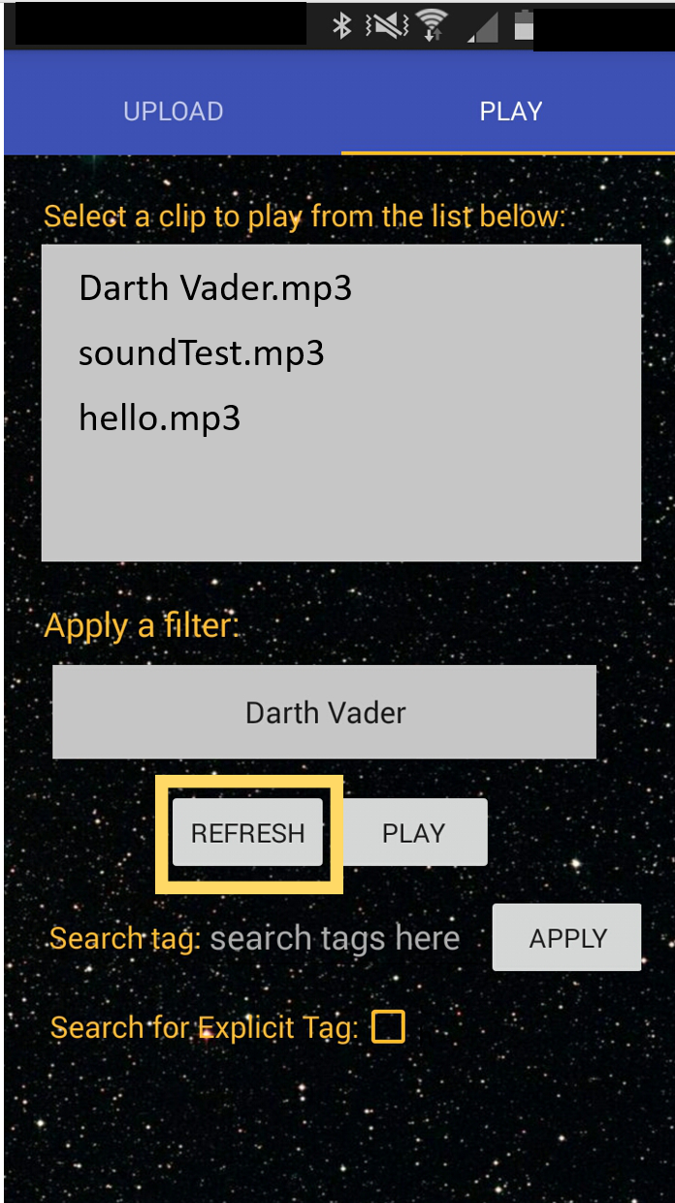

Figure 30: Press the “Refresh” button to see search results

**5 Bluetooth**

Bluetooth is an operation that is necessary for the application, however it is not mandatory that it be used by the user. Because it is used for the “Play” operation on the application, it is not necessary for the “Upload” operation of the application. The user has the option to play audio clips from the International Darth Vader product via the mobile application, or by the physical hardware buttons on the Darth Vader’s chestplate. For the mobile application, it is important to be aware of the following steps if you wish to be able to use Bluetooth for the experience.

If this is the first time you are using the application, open your Bluetooth device preferences and scan for devices. Once your device finds a device called “raspberrypi”, tap it, and select “Pair”. Please see the ***International Darth Vader****: Embedded System User Guide* for further instructions on the pairing process with the International Darth Vader product. Once you’ve received confirmation that both devices have been successfully paired to one another, then open the mobile application.

While the application shows the splash screen (or if you have tapped the screen to skip the splash screen), the application is also attempting to connect your device to the International Darth Vader product. Once the application initially displays the “Upload” screen, a message should appear at the bottom of the screen saying that the device is “successfully connected via Bluetooth”. If you have chosen to let the splash screen play out in its entirety, you will not see this message; however, you can verify a successful Bluetooth connection by navigating to the “Play” operation and tapping the “Refresh” button. If a list of available clips populates the clip list, then your device has successfully connected to the Darth Vader module. Otherwise, you will receive a connection error message that a Bluetooth connection has not yet been established. If this is the case, please wait for a couple seconds before tapping the “Refresh” button again. If you continue to tap the “Refresh” button and audio clips do not populate the clip list, completely close down and restart the application. If the issue persists, contact the mobile application developer (see Section 6).

**6 Questions about this Mobile App**

If there are any additional questions or concerns about the mobile app, please contact the mobile application developer directly at [rewilli5@ncsu.edu](mailto:rewilli5@ncsu.edu). Please begin the subject line with “IDV App:” followed by your question or concern so the developer will be able to locate and respond to it accordingly. Please try to provide as much information as possible to be able to help the developer understand the entirety of your question so that they can address the issue.

1. All device screenshots were taken with a Samsung Galaxy Note II running Android version 4.4.2. Please note that not all Android devices will use the exact steps illustrated throughout the user guide as each device is different and may feature a different yet similar set of steps to achieve the same result. If you have trouble navigating through your device to find your specific device information, please consult the user guide for your specific device.
2. This application will not access anything other than what has been outlined in this user guide. Your personal information will never be shared while the application is running or when the application has been closed. All application operations will cease once it has been completely closed. If you feel the application is displaying suspicious behavior or asks permission to use anything else other than what has been specified, completely close down and restart the application. If the behavior persists, contact the mobile application developer (see section 6).
3. A hashtag is a word or phrase preceded by a hash or pound sign (#) used to identify messages on a specific topic. It is commonly seen on different social media platforms to characterize a subject by a topic or range of topics.
4. This does not apply to audio clips that have already been uploaded when the “Upload” button is pressed (see Upload Button). It only applies to clips that have been recorded and stopped by the user, but the “Record” button is pressed again prior to pressing the “Upload” button.